Wizard Arena

The objective of the game is to kill the other players. The player with the most kills after the time has run out wins. One shot kills.

Controls

* To move, use the left analog stick left or right
* To jump move the left analog stick up.
* To shoot, use the right analog stick to aim, and while aiming use the right trigger to shoot the direction you are aiming.
* To use a utility, use the left trigger.
* If you pick up a rune (a floating capsule), your weapon will change. The color indicates the weapon.
* Players can cling to walls as well as jump off of walls
* Moving the left analog stick down while in the air will make you wall faster

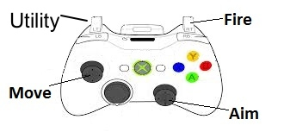Utilities

* Dash

A player that uses dash will quickly slide the direction they are moving. They will also not be effected by gravity while dashing.

* Phase

A player with phase can become temporarily invulnerable. When doing to they stop moving, but become immune to other players’ shots.

* Reflect

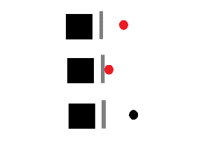A player with reflect can summon a small shield where they are aiming for a short time. The shield reflects all projectiles that hit it. If another player is hit by a projectile that you have reflected, you get the kill.

* Clone

A player with clone can throw a clone of himself in the direction they are aiming.

Runes

* Red

This spell lobs a projectile that is effected by gravity. When the projectile collides with a surface it explodes dealing damage in an area around where it exploded.

* Green

This spell shoots a slow moving projectile that will bounce off walls up to 4 times

* Blue

This spell shoots multiple projectiles a very short range, but fires very quickly.

* Orange

This spell fires projectiles in a starburst pattern. It will hit any nearby players.